SIMATS ENGINEERING
ASSESSMENT TOOL 1

COURSE NAME: INTERNET PROGRAMMING
COURSE CODE: CSA43

COURSE OUTCOME COVERED

CO 3: Implement dynamic web applications by utilizing DOM-based client-side scripting and employing Java Servlets for server-side request processing and response handling. (L3)

Assessment Tool : Scenario-Based Assessment

Weightage: 40%
Dr.V.Parthipan

QUESTIONS: Total Marks: 30

Question 1
Suppose that a college wants to develop an online student registration system where students submit their details through a web form, and the data is processed using a Java Servlet.
Explain the architecture of a servlet-based application. Design and implement a servlet to handle form data using both GET and POST methods. Describe the servlet life cycle (init, service, destroy) and justify which method is more appropriate for handling sensitive data.

Solution :

```html
<!DOCTYPE html>
<html>
<head>
<title>Student Registration System</title>

<style>
body {
font-family: Arial;
background-color: lightblue;
}

.container {
width: 400px;
margin: 50px auto;
padding: 20px;
background-color: white;
border-radius: 10px;
}

h2 {
text-align: center;
}

label {
display: block;
margin-top: 10px;
}

input, select {
width: 100%;
padding: 8px;
margin-top: 5px;
}

.button {
margin-top: 15px;
width: 48%;
padding: 10px;
background-color: green;
color: white;
border: none;
cursor: pointer;
}

.reset {
background-color: red;
}
</style>
</head>

<body>

<div class="container">

<h2>Student Registration</h2>

<!-- POST Method -->
<form action="StudentServlet" method="post">

<label>Student Name:</label>
<input type="text" name="studentName" required>

<label>Register Number:</label>
<input type="text" name="registerNumber" required>

<label>Email:</label>
<input type="email" name="email" required>

<label>Password:</label>
<input type="password" name="password" required>

<label>Department:</label>
<select name="department">
<option value="CSE">Computer Science Engineering</option>
<option value="IT">Information Technology</option>
<option value="ECE">Electronics and Communication</option>
<option value="EEE">Electrical and Electronics</option>
</select>

<label>Year:</label>
<select name="year">
<option value="1">First Year</option>
<option value="2">Second Year</option>
<option value="3">Third Year</option>
<option value="4">Fourth Year</option>
</select>

<input type="submit" value="Register" class="button">
<input type="reset" value="Clear" class="button reset">

</form>

<br>

<hr>

<h3>GET Method</h3>

<!-- GET Method -->
<form action="StudentServlet" method="get">

<label>Enter Register Number:</label>
<input type="text" name="registerNumber" required>

<input type="submit" value="Search Student" class="button">

</form>

</div>

</body>
</html>
```

Output :
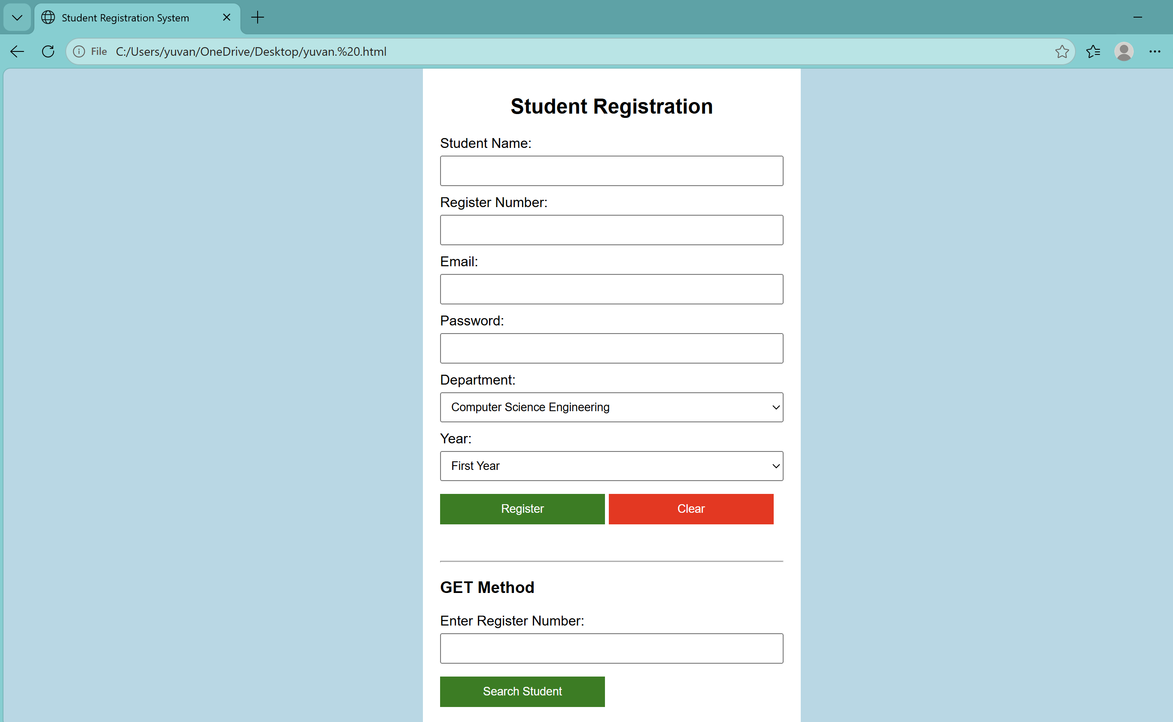

Question 2
Suppose that a website requires users to log in and maintain their session across multiple pages after authentication.
Design a session management system using HttpSession and Cookies in Servlets. Explain how session tracking works in web applications and compare session-based tracking with cookies.

Solution :

```html
<!DOCTYPE html>
<html>
<head>
<title>Student Login System</title>

<style>
body {
font-family: Arial;
background-color: lightblue;
margin: 0;
}

.container {
width: 500px;
margin: 40px auto;
background-color: white;
padding: 25px;
border-radius: 10px;
box-shadow: 0px 0px 10px gray;
}

h1, h2 {
text-align: center;
}

input {
width: 95%;
padding: 10px;
margin: 8px 0;
}

button {
padding: 10px 20px;
margin: 5px;
border: none;
background-color: green;
color: white;
cursor: pointer;
}

.logout {
background-color: red;
}

.page {
display: none;
}

.info {
background-color: #eeeeee;
padding: 15px;
margin-top: 15px;
}

table {
width: 100%;
border-collapse: collapse;
margin-top: 15px;
}

th, td {
border: 1px solid black;
padding: 8px;
text-align: center;
}

th {
background-color: lightgray;
}
</style>
</head>

<body>

<div class="container">

<h1>Student Login System</h1>

<!-- LOGIN PAGE -->
<div id="loginPage" class="page">

<h2>Login</h2>

<input type="text" id="username"
placeholder="Enter Username">

<input type="password" id="password"
placeholder="Enter Password">

<button onclick="login()">Login</button>

</div>

<!-- HOME PAGE -->
<div id="homePage" class="page">

<h2>Home Page</h2>

<p id="welcome"></p>

<button onclick="showProfile()">Profile</button>

<button onclick="showSession()">Session Details</button>

<button onclick="showComparison()">Compare</button>

<button class="logout" onclick="logout()">Logout</button>

<div id="content"></div>

</div>

<!-- COMPARISON PAGE -->
<div id="comparisonPage" class="page">

<h2>Session Tracking Comparison</h2>

<table>

<tr>
<th>HttpSession</th>
<th>Cookies</th>
</tr>

<tr>
<td>Data is maintained on server</td>
<td>Data is stored in browser</td>
</tr>

<tr>
<td>Suitable for login sessions</td>
<td>Useful for preferences</td>
</tr>

<tr>
<td>Can store objects</td>
<td>Stores small text values</td>
</tr>

<tr>
<td>Session can be invalidated</td>
<td>Cookie can be deleted</td>
</tr>

<tr>
<td>More suitable for sensitive data</td>
<td>Should not store passwords</td>
</tr>

</table>

<br>

<button onclick="goHome()">Back to Home</button>

</div>

</div>

<script>

/* Show Login Page */
document.getElementById("loginPage").style.display = "block";

/* LOGIN */
function login() {

var username =
document.getElementById("username").value;

var password =
document.getElementById("password").value;

if (username == "student" && password == "12345") {

/* Simulate HttpSession */
sessionStorage.setItem("username", username);

/* Create Cookie */
document.cookie =
"username=" + username +
"; max-age=3600; path=/";

document.getElementById("loginPage").style.display =
"none";

document.getElementById("homePage").style.display =
"block";

document.getElementById("welcome").innerHTML =
"<b>Welcome " + username + "!</b><br>" +
"You are successfully logged in.";

} else {

alert("Invalid Username or Password");

}
}

/* PROFILE */
function showProfile() {

var username =
sessionStorage.getItem("username");

document.getElementById("content").innerHTML =

"<div class='info'>" +
"<h3>Student Profile</h3>" +
"Username: " + username + "<br>" +
"Status: Logged In<br>" +
"Session: Active" +
"</div>";
}

/* SESSION DETAILS */
function showSession() {

var username =
sessionStorage.getItem("username");

document.getElementById("content").innerHTML =

"<div class='info'>" +
"<h3>Session Information</h3>" +
"Username: " + username + "<br>" +
"Session Status: Active<br>" +
"Session Storage: sessionStorage<br>" +
"Cookie: " + getCookie("username") +
"</div>";
}

/* READ COOKIE */
function getCookie(name) {

var cookies = document.cookie.split(";");

for (var i = 0; i < cookies.length; i++) {

var cookie = cookies[i].trim();

if (cookie.indexOf(name + "=") == 0) {

return cookie.substring(
name.length + 1
);
}
}

return "Cookie not found";
}

/* LOGOUT */
function logout() {

/* Destroy session */
sessionStorage.removeItem("username");

/* Delete cookie */
document.cookie =
"username=; max-age=0; path=/";

document.getElementById("homePage").style.display =
"none";

document.getElementById("comparisonPage").style.display =
"none";

document.getElementById("loginPage").style.display =
"block";

document.getElementById("username").value = "";

document.getElementById("password").value = "";
}

/* SHOW COMPARISON */
function showComparison() {

document.getElementById("homePage").style.display =
"none";

document.getElementById("comparisonPage").style.display =
"block";
}

/* GO HOME */
function goHome() {

document.getElementById("comparisonPage").style.display =
"none";

document.getElementById("homePage").style.display =
"block";
}

</script>

</body>
</html>
``` 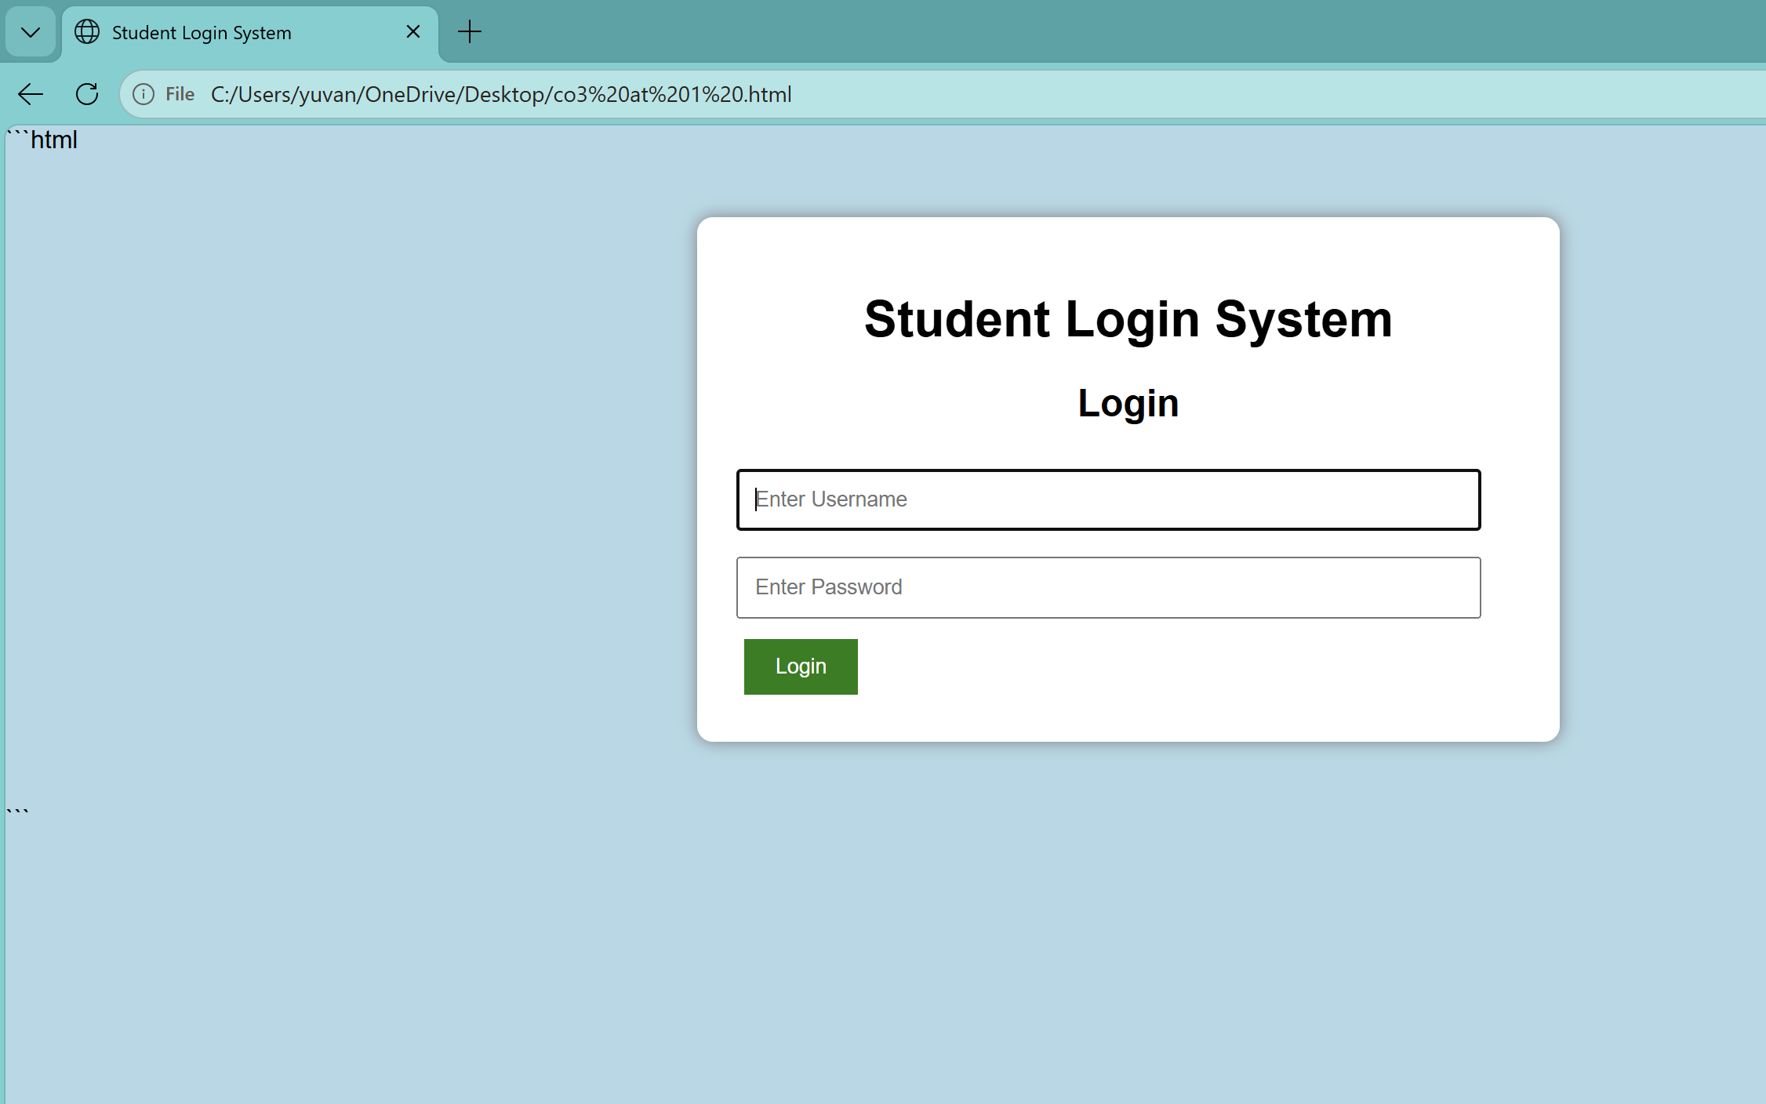
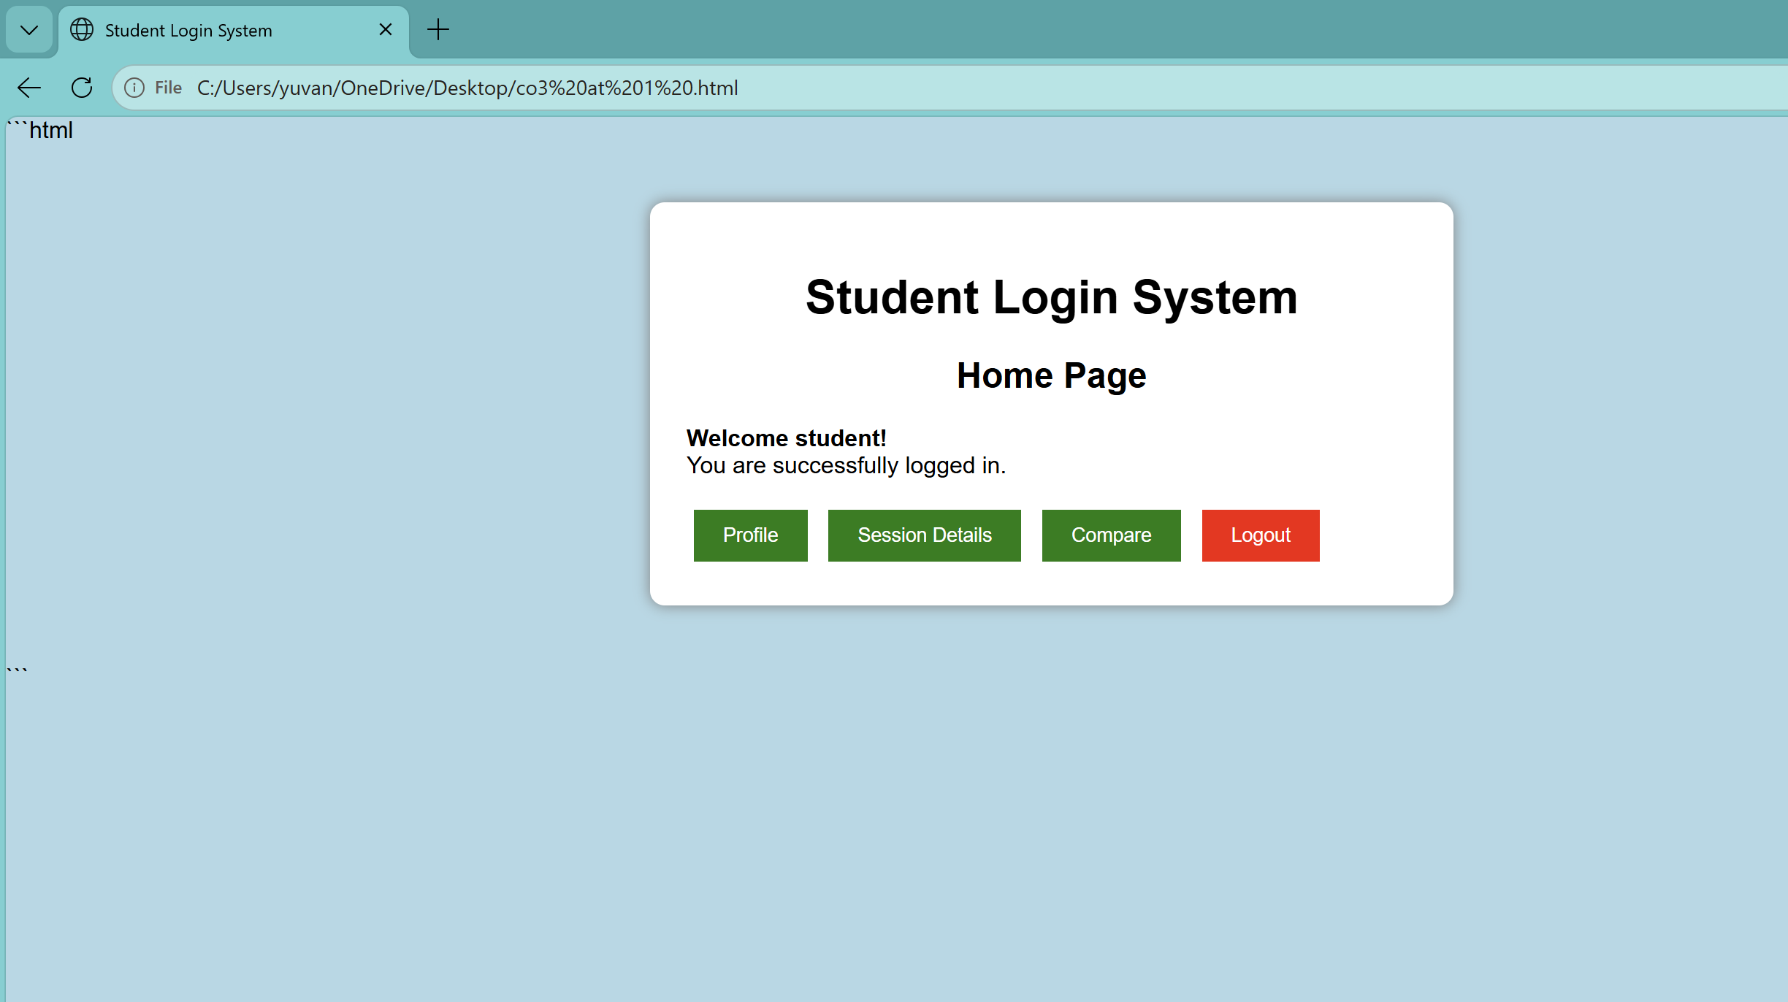

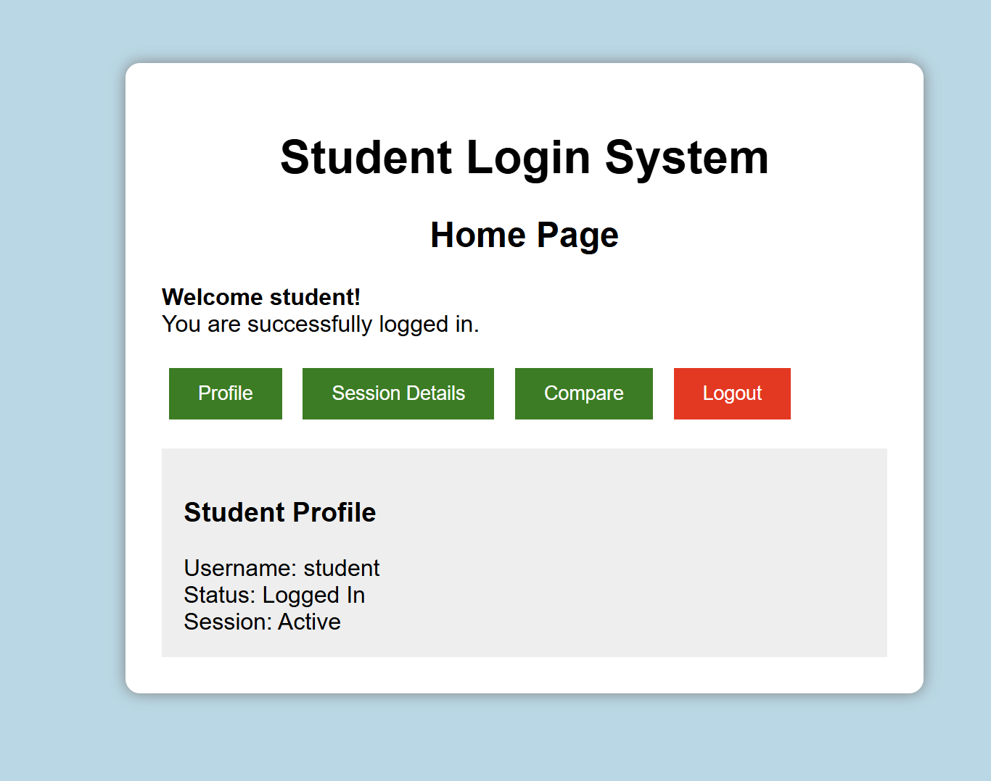

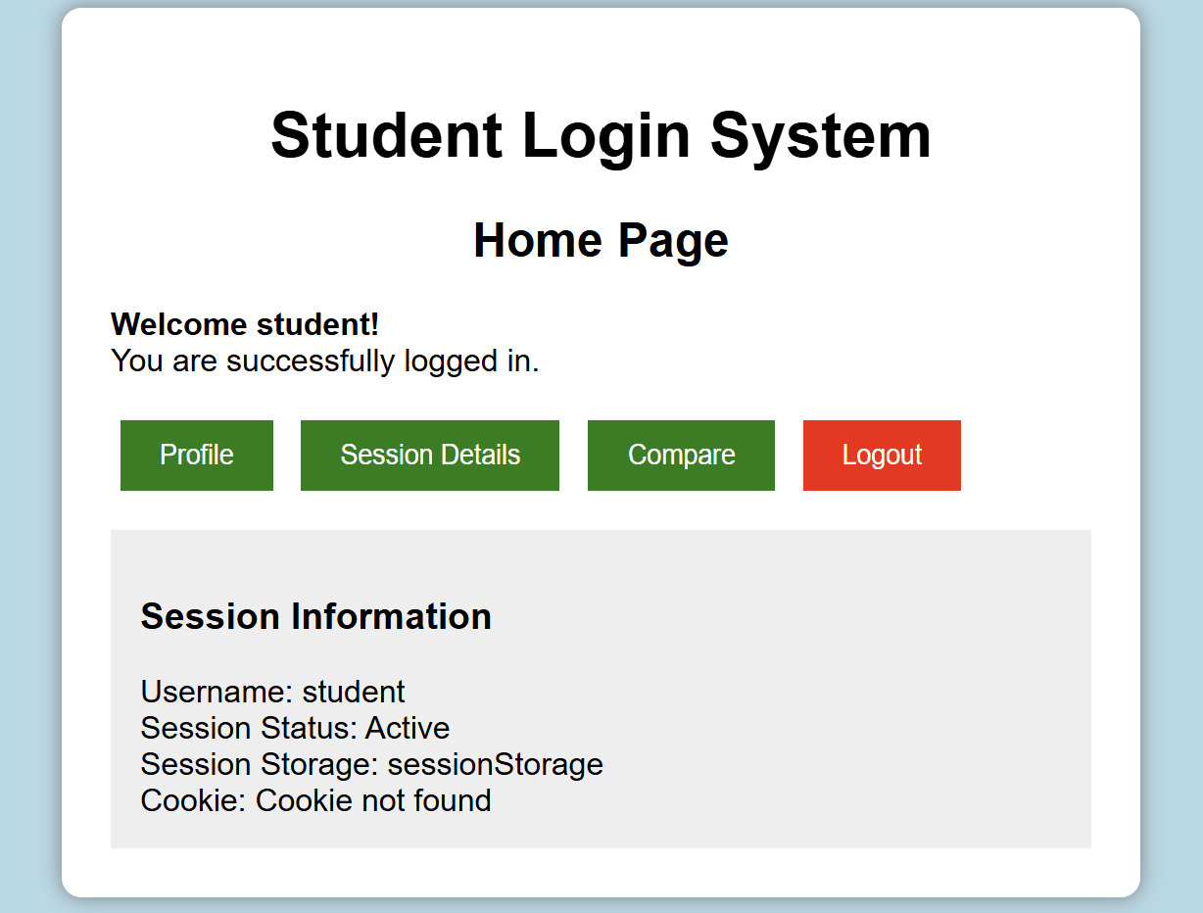

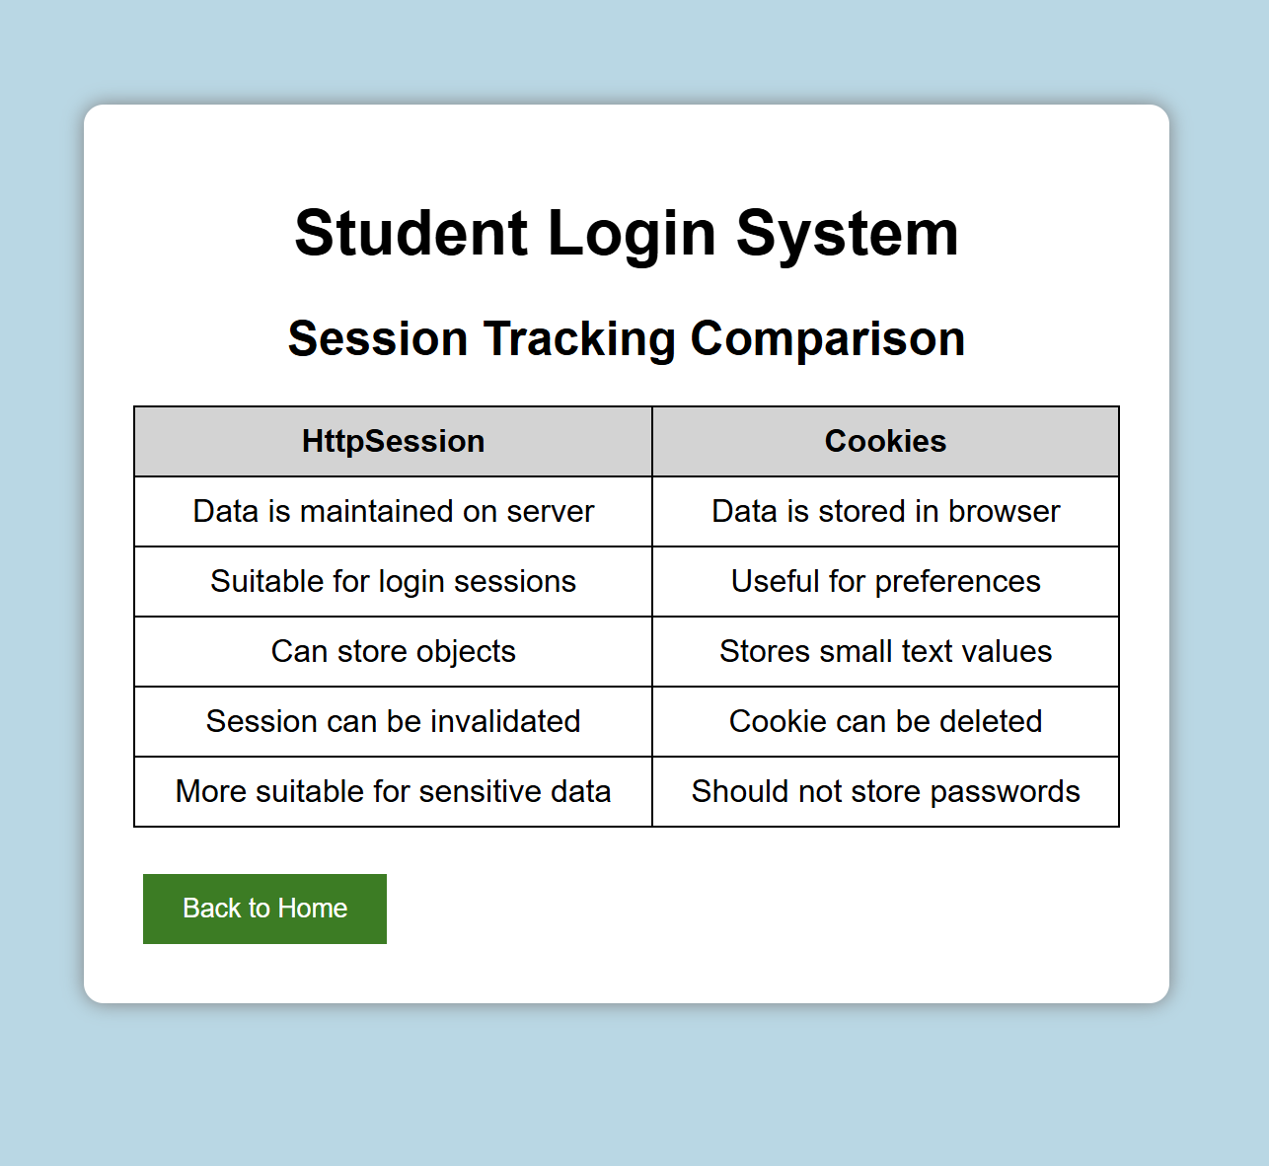

Question 3
Suppose that an e-commerce platform needs to store and retrieve product details from a database using a Java-based web application.
Design a JDBC-based application to connect to a database, insert product data, and retrieve it using SQL queries. Explain the JDBC architecture and describe the steps involved in database connectivity along with proper exception handling.

Solution :

```html
<!DOCTYPE html>
<html>
<head>

<title>E-Commerce Product Management</title>

<style>

body {
font-family: Arial;
background-color: lightblue;
margin: 0;
}

.container {
width: 800px;
margin: 40px auto;
background-color: white;
padding: 25px;
border-radius: 10px;
box-shadow: 0px 0px 10px gray;
}

h1 {
text-align: center;
}

h2 {
text-align: center;
}

input {
width: 95%;
padding: 10px;
margin: 8px 0;
}

button {
padding: 10px 20px;
margin: 5px;
border: none;
background-color: green;
color: white;
cursor: pointer;
}

.clear {
background-color: red;
}

table {
width: 100%;
border-collapse: collapse;
margin-top: 20px;
}

th, td {
border: 1px solid black;
padding: 10px;
text-align: center;
}

th {
background-color: lightgray;
}

.message {
margin-top: 15px;
padding: 10px;
background-color: #eeeeee;
}

</style>

</head>

<body>

<div class="container">

<h1>E-Commerce Product Management</h1>

<h2>Add Product</h2>

<!-- PRODUCT FORM -->

<input type="text"
id="productId"
placeholder="Enter Product ID">

<input type="text"
id="productName"
placeholder="Enter Product Name">

<input type="number"
id="price"
placeholder="Enter Product Price">

<input type="number"
id="quantity"
placeholder="Enter Quantity">

<br>

<button onclick="insertProduct()">
Insert Product
</button>

<button onclick="retrieveProducts()">
Retrieve Products
</button>

<button class="clear"
onclick="clearProducts()">
Clear Database
</button>

<div id="message"
class="message">

Database is ready.

</div>

<!-- PRODUCT TABLE -->

<h2>Product Details</h2>

<table>

<thead>

<tr>

<th>Product ID</th>

<th>Product Name</th>

<th>Price</th>

<th>Quantity</th>

</tr>

</thead>

<tbody id="productTable">

</tbody>

</table>

</div>

<script>

/*
Simulating a database using an array
*/

var products = [];

/*
INSERT PRODUCT
*/

function insertProduct() {

var id =
document.getElementById("productId").value;

var name =
document.getElementById("productName").value;

var price =
document.getElementById("price").value;

var quantity =
document.getElementById("quantity").value;

/*
Exception / validation handling
*/

if (id == "" ||
name == "" ||
price == "" ||
quantity == "") {

alert("Please enter all product details.");

return;
}

/*
Check duplicate Product ID
*/

for (var i = 0; i < products.length; i++) {

if (products[i].id == id) {

alert("Product ID already exists.");

return;
}
}

/*
Create product object
*/

var product = {

id: id,

name: name,

price: price,

quantity: quantity

};

/*
Insert product
*/

products.push(product);

document.getElementById("message").innerHTML =

"Product inserted successfully!";

/*
Clear input fields
*/

document.getElementById("productId").value = "";

document.getElementById("productName").value = "";

document.getElementById("price").value = "";

document.getElementById("quantity").value = "";

retrieveProducts();

}

/*
RETRIEVE PRODUCTS
*/

function retrieveProducts() {

var table =
document.getElementById("productTable");

table.innerHTML = "";

if (products.length == 0) {

document.getElementById("message").innerHTML =

"No products found in database.";

return;
}

/*
Retrieve each product
*/

for (var i = 0; i < products.length; i++) {

var row =
table.insertRow();

row.insertCell(0).innerHTML =
products[i].id;

row.insertCell(1).innerHTML =
products[i].name;

row.insertCell(2).innerHTML =
"₹" + products[i].price;

row.insertCell(3).innerHTML =
products[i].quantity;

}

document.getElementById("message").innerHTML =

"Products retrieved successfully.";

}

/*
CLEAR DATABASE
*/

function clearProducts() {

if (confirm(
"Are you sure you want to clear all products?"
)) {

products = [];

document.getElementById("productTable").innerHTML =
"";

document.getElementById("message").innerHTML =

"Database cleared successfully.";

}

}

</script>

</body>

</html>
```

Output:
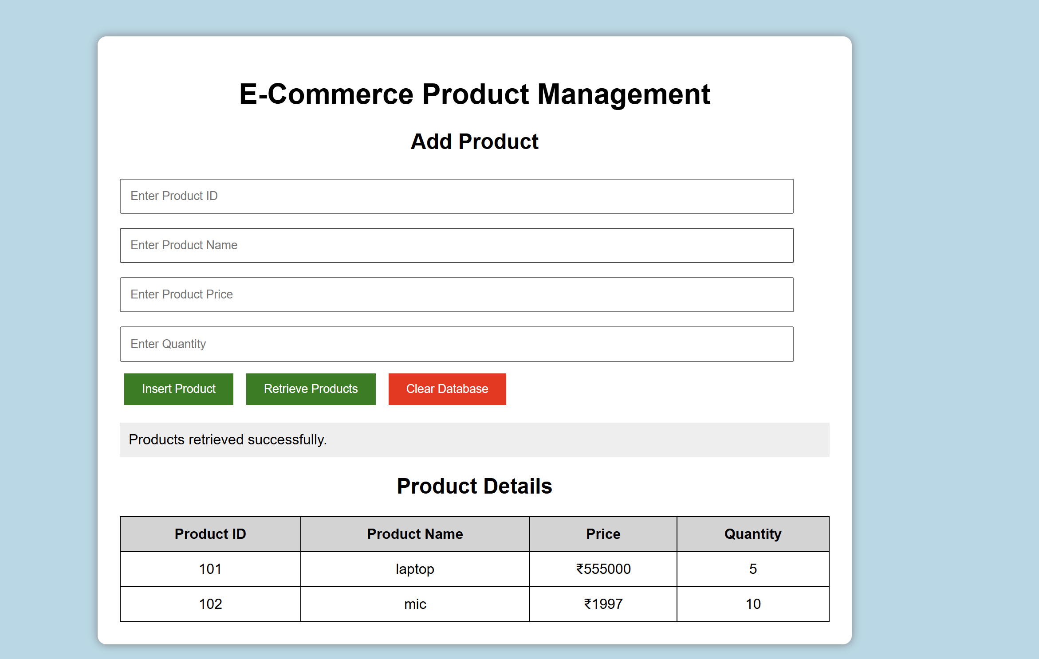

Code of Conduct:

I yuvan shankar (192511072) certify that this submission is my original work and that I have adhered to the guidelines specified for this assessment.
I understand that any violation of academic integrity rules will result in disciplinary action.

Signature of the student:
Yuvanshankar l

RUBRICS FOR CALCULATION:

Criteria | Weightage (%) | Level 4 (Exemplary) | Level 3 (Proficient) | Level 2 (Developing) | Level 1 (Beginning)
Understanding of Scenario | 20% | Demonstrates clear and complete understanding of the scenario and context | Shows good understanding with minor gaps | Partial understanding; misses key aspects | Misinterprets or fails to understand the scenario
Identification of Key Issues | 20% | Accurately identifies all relevant issues and factors involved | Identifies most key issues with minor omissions | Identifies limited issues; some irrelevant points | Unable to identify key issues
Application of Concepts | 25% | Applies appropriate concepts effectively to address the scenario | Applies concepts with minor errors | Limited or partially correct application | Unable to apply relevant concepts
Decision Making | 20% | Makes well-reasoned, logical decisions with strong rationale | Makes reasonable decisions with some justification | Makes weak decisions with limited justification | No clear decisions made or rationale provided
Clarity of Response | 15% | Response is clear, structured, and logically presented | Generally clear with minor issues | Somewhat unclear or poorly structured | Disorganized and difficult to understand

